**1)Find the mail servers of the following domain**

**Ibm.com**

**Wipro.com**

**(I didn’t get the output but I hope I have done the steps correctly so submitting the assignment, pardon me!)**

Open the Packet Tracer

Connect two end devices of different IP address with a copper wire with a switch

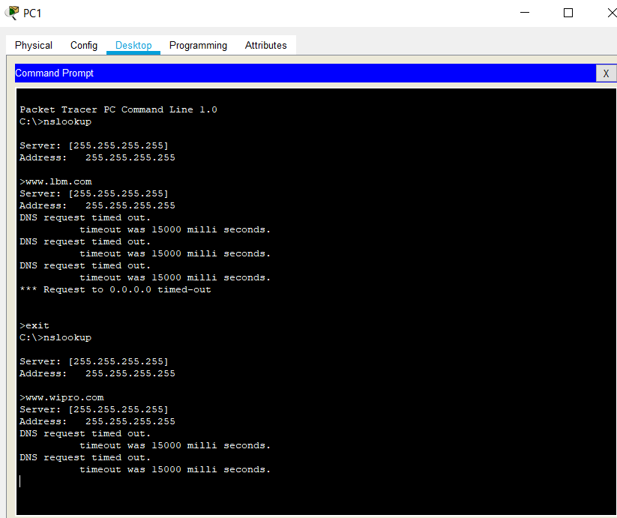Then left click ->Desktop->open command prompt

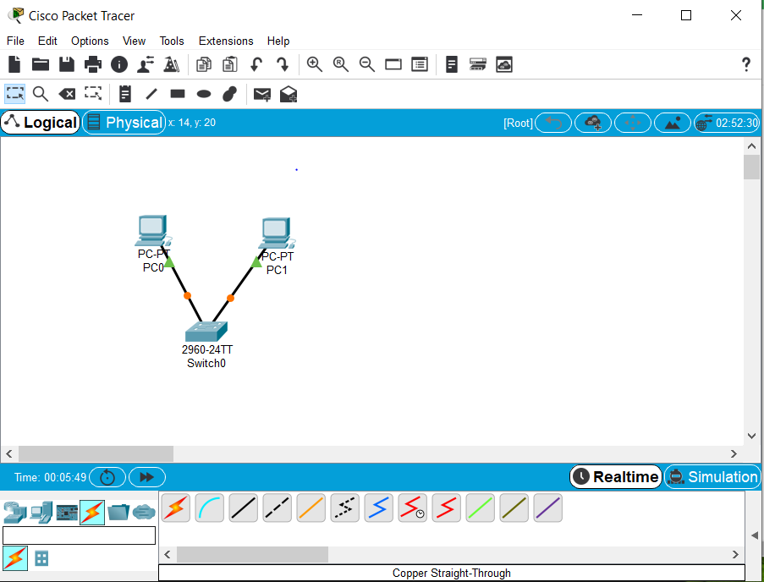

[www.Ibm.com](http://www.Ibm.com)

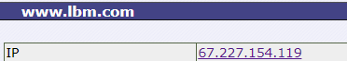 Command : nslookup

Expected output

[www.wipro.com](http://www.wipro.com)

